SonarQube For Java Application

Install sonarQube in server to add the database
Go to config file and select sonar file then edit the sonar properties file
edit sonar.propertirs file
sonar.jdbc.username=Dev_Ops
sonar.jdbc.password=admin123
# Use the following connection string if you want to use SQL Auth while connecting to MS Sql Server.
# Set the sonar.jdbc.username and sonar.jdbc.password appropriately.
sonar.jdbc.url=jdbc:sqlserver://10.78.25.84:1443;databaseName=Dev_Ops
sonar.web.host=0.0.0.0
sonar.web.port=9500
install sonarscanner and go to sonar-scanner file edit the sonar-scanner.properties file
edit the sonar-scanner.properties file
sonar.host.url=http://10.75.21.110:9500
sonar.login=c8325b1f0dee631620974534c87d9a4b4cf180c6
sonar.sources=.
sonar.sourceEncoding=UTF-8
integrate sonarqube with Jenkins
Step1: Go to manage jenkins -->manage plugins-->upload this plugins 1)Sonar Quality Gate Plugin 2)Sonar Qube Scanner f0r jenkins
Step2: go to manage jenkins -->configure System-->add sonarqube details
SonarQube Configuration in jenkins
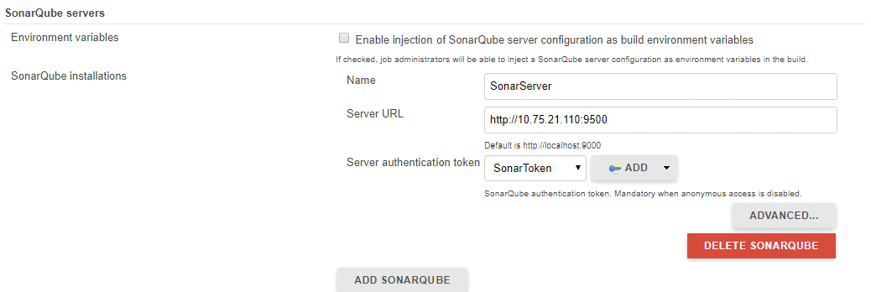
Step3: Go to manage jenkins --> Global tool configurations-->add sonarqube scanner details
SonarQube Scanner Configuration
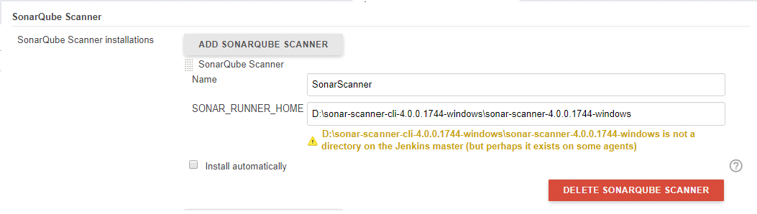
Maven Configuration
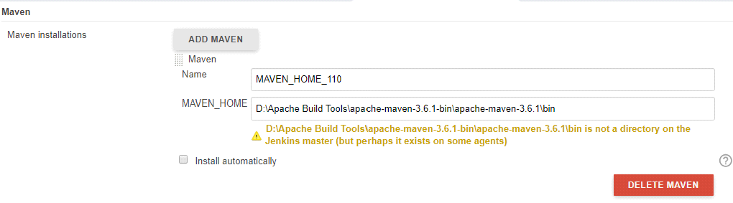
Java Configuration
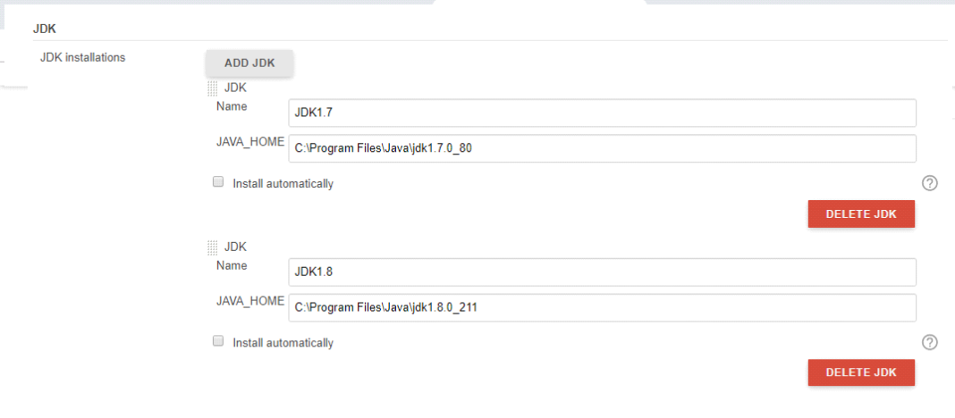
Step4: create jenkins pipeline job
Jenkins pipeline job
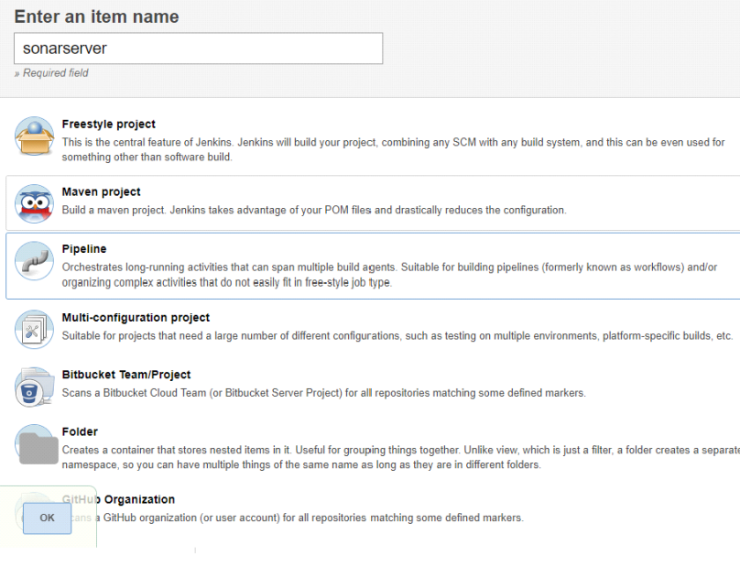
Jenkins pipeline script

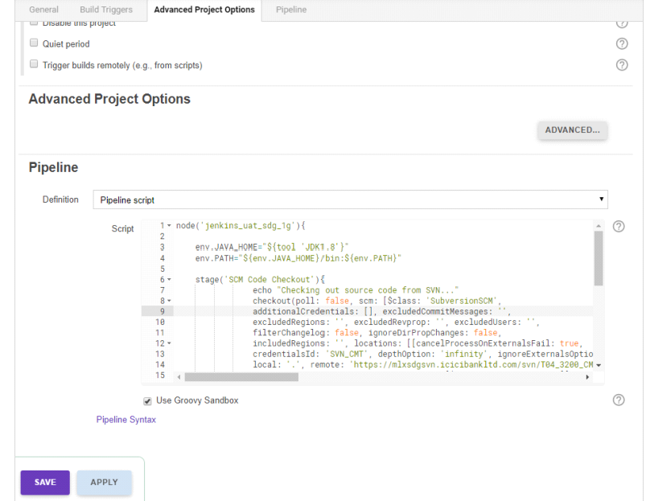
Jenkins file code
node('jenkins_uat_sdg_1g'){
env.JAVA_HOME="${tool 'JDK1.7'}"
env.PATH="${env.JAVA_HOME}/bin:${env.PATH}"
try{
try{
stage('SCM Code Checkout'){
echo "Checking out source code from SVN..."
checkout(poll: false, scm: [$class: 'SubversionSCM',
additionalCredentials: [], excludedCommitMessages: '',
excludedRegions: '', excludedRevprop: '', excludedUsers: '',
filterChangelog: false, ignoreDirPropChanges: false,
includedRegions: '', locations: [[cancelProcessOnExternalsFail: true,
credentialsId: 'SVN_CMT', depthOption: 'infinity', ignoreExternalsOption: true,
local: '.', remote: 'https://mlxsdgsvn.icicibankltd.com/svn/T04_3200_CMART/CMART/SourceCode/${folderName}']],
quietOperation: true, workspaceUpdater: [$class: 'UpdateUpdater']])
echo "successfully checked out from SVN"
}
} catch(error){
println("Unable to checkout...there were some errors!")
currentBuild.result = "FAILURE"
error()
}
try{
stage('Compile & Package Generation'){
echo "Begining to compile the code"
bat label: 'maven-phase', script: '"D:\\Apache Build Tools\\apache-maven-3.6.1-bin\\apache-maven-3.6.1\\bin\\mvn" -o -f parent/pom.xml clean install -e'
echo "Successfully compiled"
}
}catch(error){
println("Unable to compile...there were some errors!")
currentBuild.result = "FAILURE"
error()
}
try{
stage('SonarQube'){
withMaven(jdk: 'JDK1.8', maven: 'MAVEN_HOME_110'){
withSonarQubeEnv('SonarServer'){
bat label: 'sonar-analyis', script: '"D:/Apache Build Tools/apache-maven-3.6.1-bin/apache-maven-3.6.1/bin/mvn" org.sonarsource.scanner.maven:sonar-maven-plugin:3.6.0.1398:sonar -f parent/pom.xml -Dsonar.host.url=http://10.75.21.110:9500 -Dsonar.login=c8325b1f0dee631620974534c87d9a4b4cf180c6'
}
}
}
}catch(err){
println("Unable to perform code quality analysis!")
currentBuild.result = "FAILURE"
error()
}
try{
stage('Sonar QG'){
timeout(time: 5, unit: 'MINUTES'){
def qg = waitForQualityGate()
if(qg.status != 'OK'){
error "Pipeline aborted due to quality gate failure: ${qg.status}"
}
}
}
}catch(err){
println("Quality gate computation has somehow failed")
currentBuild.result = "FAILURE"
error()
createJira()
}
Step5: browse 10.75.21.110:9500 for sonarQube.
SonarQube Dashboard
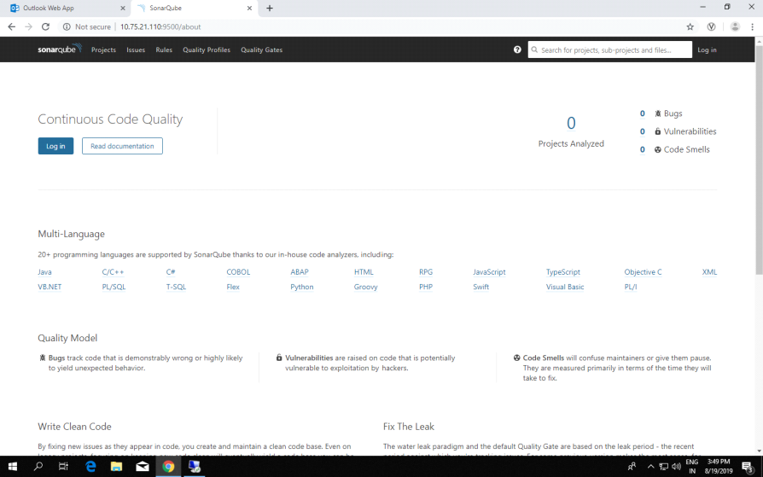

sonarqube project dashboard
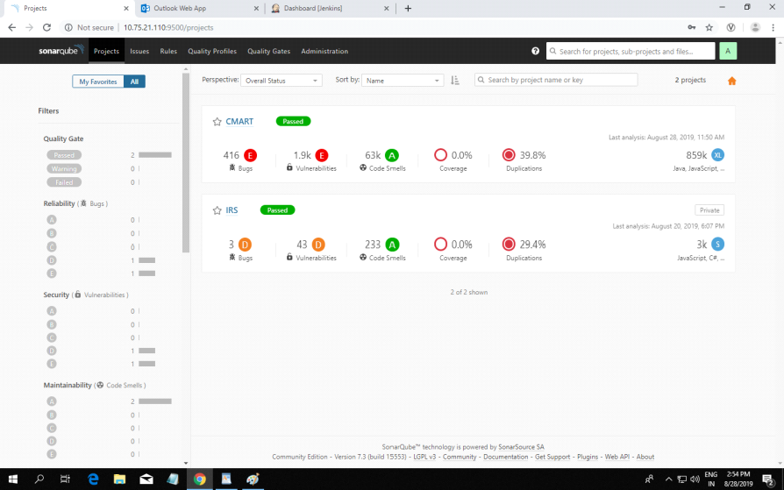
creating webhooks
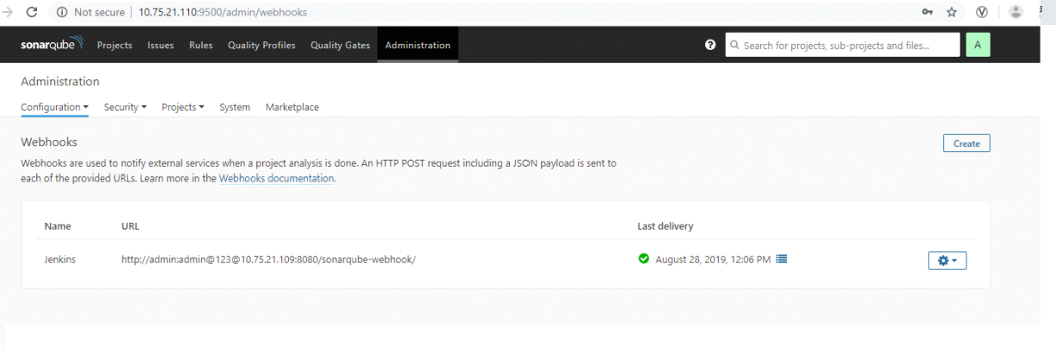
-------------------------------------------------------------------------------------------------------------------

SonarScanner for .Net

